Software Requirement Specifications
Car Rental Portal


Submitted by
Muhammad Mubarak Abbasi (F22BINFT1E02097)
Submitted to
Dr.Musarat Karim

Department of Information Technology
Faculty of Computing
The Islamia University of Bahawalpur
Summary
The "Car Rental Portal" project aims to develop a dynamic and secure web application that facilitates the online browsing, reservation, and management of rental cars. The system's core function is to ensure accurate availability checks to prevent double-booking while offering a seamless user experience suitable for all skill levels. It replaces manual booking methods with a digital solution that includes a public interface for customers and a secure admin panel for fleet management.

Table of Contents
- Introduction
1.1 Purpose
1.2 Scope
1.3 Product Perspective –
1.4 User Characteristics
1.5 Similar Apps and Systems / Literature Review
1.6 Proposed Technologies –
- Requirements
2.1 Functional Requirements
2.1.1 Sign Up
2.1.2 login
2.1.3 search car
2.1.4 book car
2.1.5 manage profile
2.1.6 admin functional requirements
2.2 Non-Functional Requirements
2.2.1 performance
2.2.2 security
2.2.3 usability
2.2.4 reliability
2.2.5 scalability
- Use Cases and Flow of Processes
3.1 Use Case 1: Sign Up
3.2 Use Case Diagram
3.3 Activity Diagram (Car Booking)
3.4 Sequence Diagram (Login)
- ERD Diagrams
4.1 ERD tables
5: Reference

Introduction
1.1 Purpose
The purpose of this SRS (Software Requirements Specification) document is to describe the functional and non-functional requirements of the Car Rental System developed using PHP, MySQL, HTML/CSS/JS. The document is intended for developers, project managers, testers, and stakeholders.

1.2 Scope
The Car Rental System allows users to:
- Register and log in
- Search available cars
- Rent cars for specific dates
- Make online bookings
- View booking history
- Manage cars, users, and bookings (Admin)
This system automates the traditional manual car rental process.

1.3 Product Perspective
This system is a web-based application.
It consists of:
- Client Side: User interface for customers
- Admin Panel: For managing cars and rentals
- Server Side: PHP-based logic
- Database: MySQL to store cars, bookings, and user data
It operates as an independent platform but can integrate with:
- Online payment gateways
- SMS or Email notification services

1.4 User Characteristics
User Type | Characteristics
Customer | Basic computer knowledge, can browse cars, book rentals
Admin | Experienced computer user, manages car inventory and bookings
System Operator | Technical background, handles system-level configuration

1.5 Similar Apps and Systems / Literature Review
Existing solutions studied:
- Enterprise Rent-A-Car System
- ZoomCar Web App
- UDrive (Self-drive UAE)
- Local rental agency systems
These systems provided insight into:
- User-friendly booking workflows
- Real-time availability updates
- Payment and cancellation procedures
- Car inventory management best practices

1.6 Proposed Technologies
- Frontend: HTML5, CSS3, JavaScript, Bootstrap
- Backend: PHP 8+
- Database: MySQL
- Web Server: Apache
- Tools: phpMyAdmin, VS Code
- Optional: cURL API, JSON, AJAX

2. Requirements
2.1 Functional Requirements
2.1.1 Sign Up
Description:
Allows new users to create an account.
Functional Requirements:
- User must enter:
- Full Name
- Email
- Password
- Phone Number
- System validates email format.
- System checks if user already exists.
- Password must be encrypted before saving.
- Successful sign-up redirects to Login page.

2.1.2 Login
- User enters email & password.
- System verifies credentials.
- On success → redirects to Dashboard.

2.1.3 Search Car
- User enters date range.
- System checks availability.
- Displays available cars with pricing.

2.1.4 Book Car
- User selects a car.
- Fills pickup and return date.
- System calculates rental amount.
- Confirm booking.

2.1.5 Manage Profile
- Update personal info
- Change password

2.1.6 Admin Functional Requirements
Admin can:
- Add/Edit/Delete cars
- Manage categories (SUV, Sedan, etc.)
- View and approve/cancel bookings
- Manage registered users
- Generate reports

2.2 Non-Functional Requirements
2.2.1 Performance
- System should load pages within 3 seconds.
- Support up to 1000 concurrent users.
2.2.2 Security
- Password encryption (bcrypt/Hash).
- SQL injection protection.
- Admin panel protected by authentication.
2.2.3 Usability
- Clean, responsive UI.
- Accessible on mobile and desktop.
2.2.4 Reliability
- 99% uptime.
- Automated backup every 24 hours.

    - Scalability
- Easily expandable car inventory.
- Supports integration with payment gateways.

3. Use Cases and Flow of Processes

3.1 Use Case 1: Sign Up
Actor: Customer
Desciption: User creates a new account.
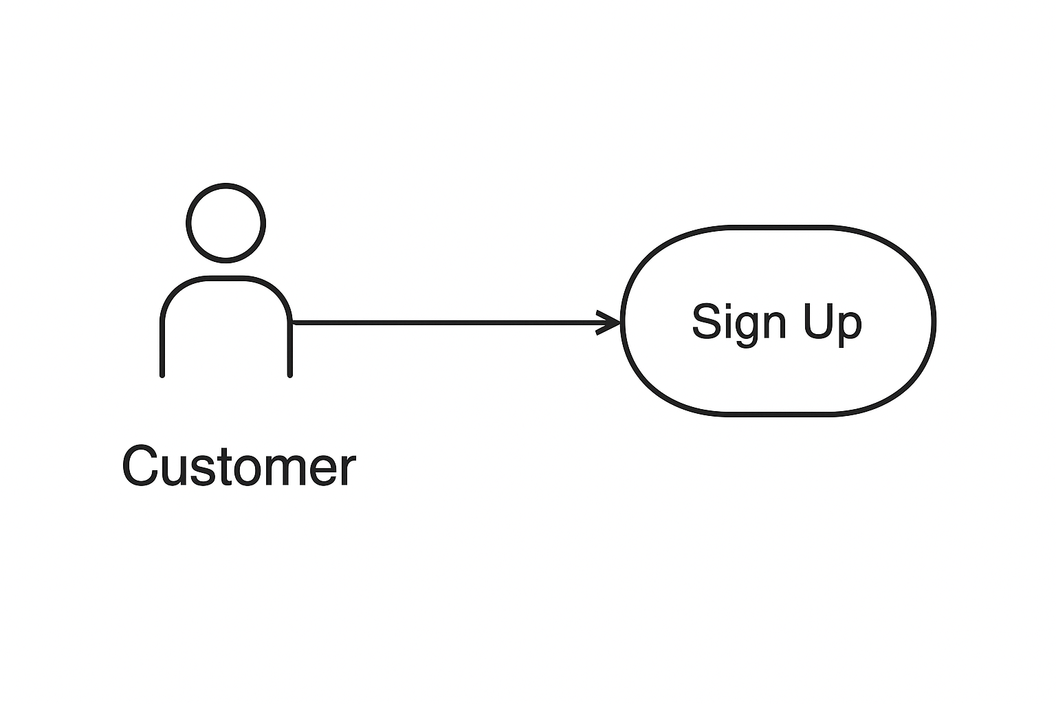

3.2 Use Case Diagram
Customer ----> (Sign Up)
Customer ----> (Login)
Customer ----> (Browse Cars)
Customer ----> (Book Car)
Admin --------> (Manage Cars)
Admin --------> (Approve Booking)
Admin --------> (Generate Reports)

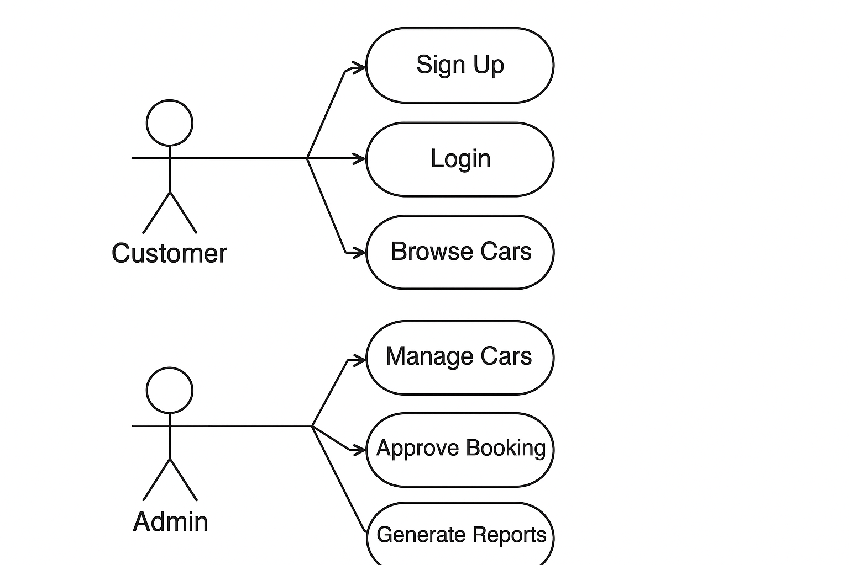
3.3 Activity Diagram (Car Booking)
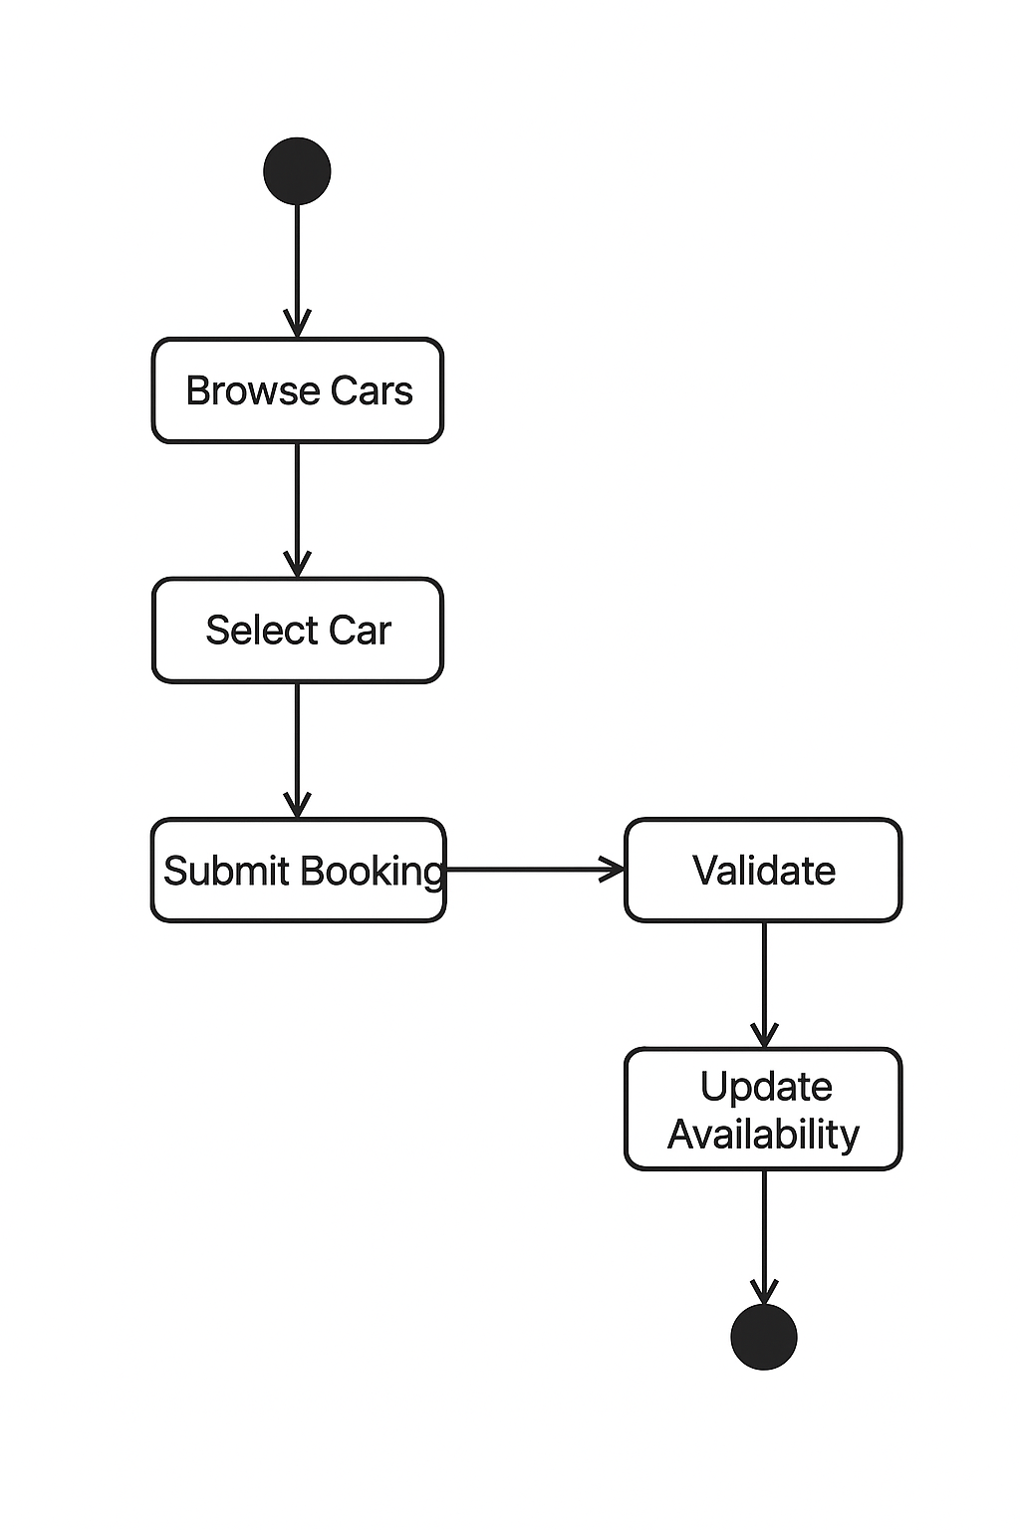
3.4 Sequence Diagram (Login)
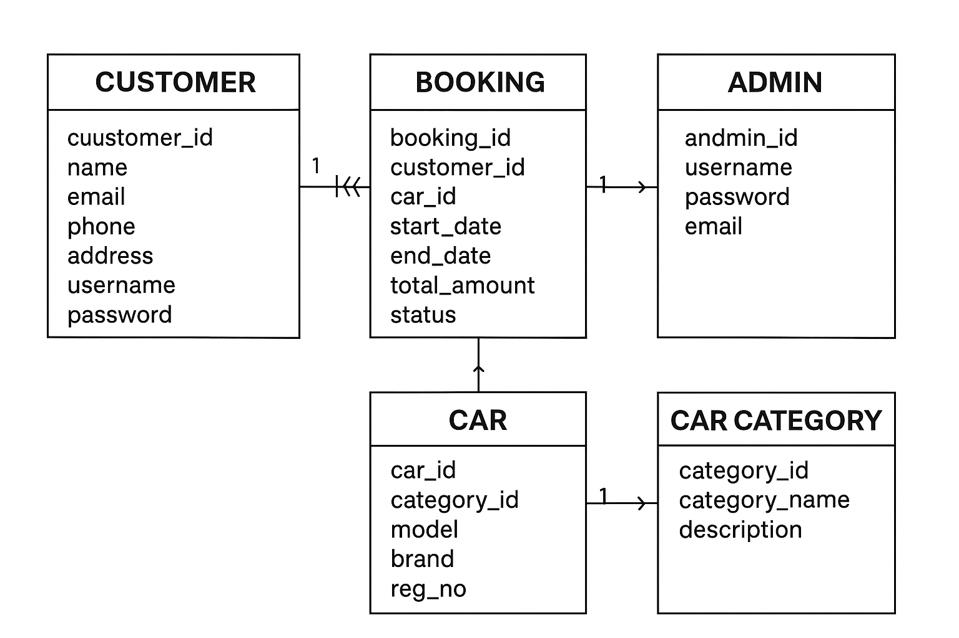

4: ERD Diagram

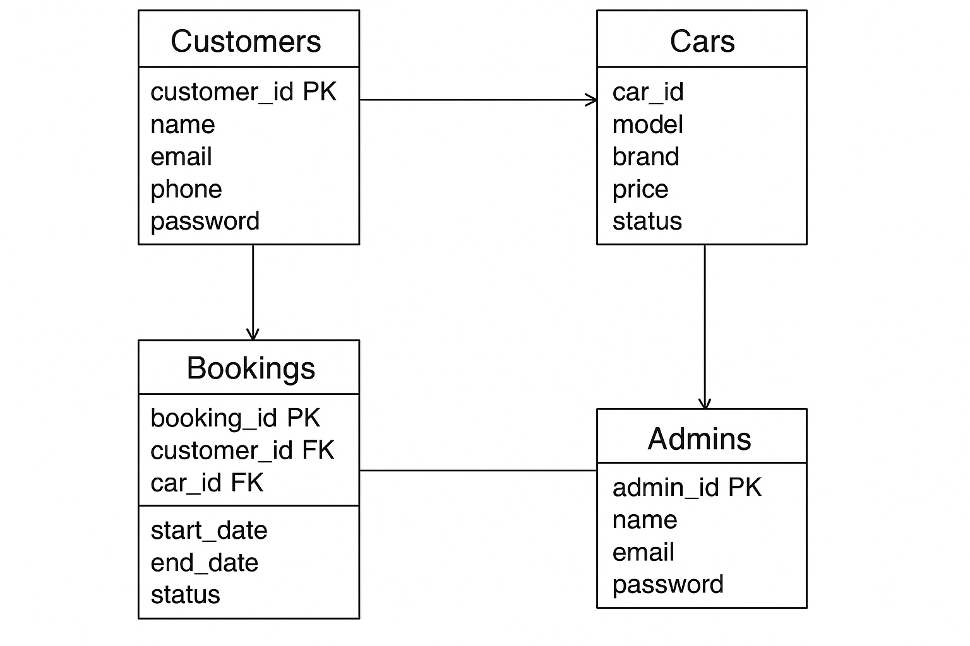

4.1 ERD (Entity Relationship Diagram)
Tables:
1. users
Field | Type
user_id | PK
full_name | VARCHAR
email | VARCHAR
password | VARCHAR
phone | VARCHAR
role | ENUM(customer/admin)

2. Cars
Field | Type
car_id | PK
model | VARCHAR
brand | VARCHAR
category | VARCHAR
price_per_day | FLOAT
status | Available/Unavailable

3. bookings
Field | Type
booking_id | PK
user_id | FK
car_id | FK
start_date | DATE
end_date | DATE
total_price | FLOAT
status | Confirmed/Cancelled
Relations:
- One user → Many bookings
- One car → Many bookings

4. References
- www.google.com
- www.w3school.com
- www.php.net.com
- www.stackoverflow.com

